 | SAKR MANNING AGENCY  FOR RECRUITING EGYPTIAN LABOR ABROAD | Issue Date | 15.05.2022
 |  | Revision Date | 27.05.2023
 | Crewing Management Manual  Seafarer Employment Application | Revision | 1.2
 |  | Page | 3
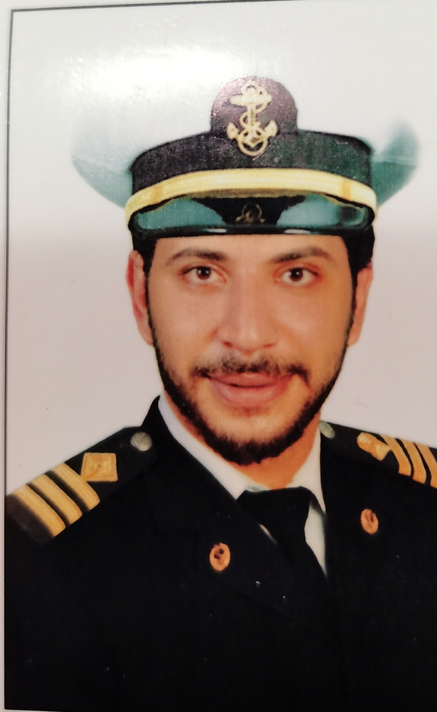
Application For Position as | THIRD ENG
Register Code. | EO-3.023
Other Position (If Any) | FOURTH ENG
Register Date | 19.09.2022
Last up Date Data
Expected Salary

1. PERSONAL DETAILS
Full Name |  | MOHAMED MAGDY MAHMOUD ELHANDAWY
Date Of Birth |  | 24/11/1992 |  |  |  |  |  | Place Of Birth |  |  |  |  |  |  | KAFR ELSHEIKH
Nationality |  | EGYPTIAN |  |  |  |  |  | Marital Status |  |  |  |  |  |  | Single X |  |  |  |  |  |  | Married
Height (Cm) |  | 185 |  |  |  |  |  | Overall Size |  |  |  |  |  |  | XXXL |  |  |  |  | Shirt Size |  |  |  |  | XXL
Weight (Kg) |  | 90 |  |  |  |  |  | Trouser Size |  |  |  |  |  |  | 38 |  |  |  |  | Shoes Size |  |  |  |  | 46
2. EDUCATION
College / School |  | BACHELOR DEGREE IN MARINE ENGINEERING IN ARAB ACADEMY COLLEGE
Marline Test |  | Issued Date |  |  |  | Result % |  |  |  | Issued By (Authority) |  |  |  |  |  |  |  |  | Issued At
English Language |  | Fluent |  |  |  |  | Good X |  |  |  |  | Average |  |  |  |  |  |  | Poor
……… Language  ( ) |  | Fluent |  |  |  |  | Good X |  |  |  |  | Average |  |  |  |  |  |  | Poor
3. CONTACT DETAILS
Home Address / City |  | BIALA /KAFR ELSHEIKH
E-Mail |  | TOTO_HENDAWIY2000@YAHOO.COM |  |  |  |  |  |  | Mobile / Tel |  |  |  |  | +201061766014

4. TRAVEL DOCUMENTS
Type |  | Document No. |  |  | ISS. Date |  |  | Exp. Date |  |  |  |  | ISS. By (Authority) |  |  |  |  |  |  |  |  | Place of Issue
Passport |  | A24545014 |  |  | 10/03/2019 |  |  | 9/3/2026 |  |  |  |  | Egyptian Authority |  |  |  |  |  |  |  |  | BIALA 39
Seaman Book |  | S00010124 |  |  | 17/10/2020 |  |  | 07/07/2025 |  |  |  |  | EAMS |  |  |  |  |  |  |  |  | Alex.
Other Seaman Book |  | PA0294146 |  |  | 28/7/2022 |  |  | 07/07/2025 |  |  |  |  | PANAMA |  |  |  |  |  |  |  |  | PIREOS DR

5. PROFESSIONAL QUALIFICATION / CERTIFICATE OF COMPETENCY
Certificate Name |  |  |  | Number | Issue Date |  |  |  |  |  | Expiry Date |  |  |  |  | Issued By |  |  |  |  |  |  |  | Issued At
COC ( Rank) ………….. |  |  |  | 5324 | 24/09/2020 |  |  |  |  |  | 07/07/2025 |  |  |  |  | EAMS |  |  |  |  |  |  |  | Alex.
GOC |  |  |  |  |  |  |  |  |  |  |  |  |  |  |  | NTRA |  |  |  |  |  |  |  | Cairo
D.P. INDUCTION
D.P. ADVANCED
D.P. OPERATOR (UNLIMITED)
6. NEXT OF KIN
Full Name | MAHMOUD MAGDY ELHENDAWIY |  |  |  |  |  |  |  |  |  |  |  |  | Relationship |  |  |  | BROTHER
Address | BIALA /KAFR ELSHEIKH
Tel. No. | +201019941128 |  |  |  |  |  |  |  | Mobile
7. HEALTH CERTIFICATES & VACCINATIONS
Flag State |  |  | Number |  |  | Issue Date |  |  |  |  | Expiry Date |  |  |  |  |  | Issued By |  |  |  |  |  | Issued At
International Medical |  |  | 00657 |  |  | 27/03/2022 |  |  |  |  | 26/03/2024 |  |  |  |  |  | EAMS |  |  |  |  |  | Alex.
Yellow Fever |  |  | 7684 |  |  | 03/03/2019 |  |  |  |  | FOR EVER |  |  |  |  |  | Ministry of Health |  |  |  |  |  | ALEX
Cholera |  |  |  |  |  |  |  |  |  |  |  |  |  |  |  |  | Ministry of Health
Covid-19 |  |  | Vaccination Name |  |  | First Dose |  |  |  |  | Second Dose |  |  |  |  |  | (Other Does or Remarks)
 |  |  | PFIZERE |  |  | 13/12/2021 |  |  |  |  | 06/02/2022

8. MARINE COURSES
Course Name | Number | Issue Date | Expiry Date | Issued By / At
Personal Survival Techniques | NR244489 | 11/8/2020 | 18/07/2025 | ALEX/NAVALINS
Proficiency In Personal Survival Techniques
Fire Prevention and Fire Fighting
Advanced Fire Prevention and Fire Fighting | NR244488 | 11/8/2020 | 11/7/2025 | ALEX/NAVAL INS
Elementary First Aid | NR244487 | 11/8/2020 | 7/7/2025 | ALEX/NAVAL INS
Medical Care Studies
Personal Safety and Social Responsibilities | NR244490 | 11/8/2020 | 14/7/2025 | ALEX/NAVAL INS
Proficiency Of Security Awareness Training Seafarers | NR243160 | 6/8/2020 | 26/7/2025 | ALEX/NAVAL INS
Proficiency as a ship Security officer ( PSSO )
Proficiency In Survival Craft & Rescue Boats | NR244491 | 11/8/2020 | 28/7/2025 | ALEX/NAVAL INS
G.M.D.S.S
Communications
Advanced Communications
ECDIS Advanced Simulator (Management Level)
ECDIS Simulator (Operation Level) | NR244492 | 11/8/2020 | 25/7/2025 | ALEX/INS
Prevention and Combating of Marine Pollution | 200085447 | 21/12/2015 | FOR EVER | ALEX/ACADEMY
Radar & ARPA Simulator and Search &rescue
ARPA Simulator and Search
Marine Radar and automatic Radar Plotting
Bridge resource Management (B.R.M)
Engine resource Management (E.R.M)
Navigational Watch keeping
Proficiency for Rating forming part of Navigational watch (II/4) |  |  |  | EAMS / Alex.
High voltage training – operation of ship (1000 Volt and More)
Passenger Safety Cargo Safety and Hull integrity | NR15056 | 28/11/2019 | 25/11/2024 | ALEX/INS
Crowd Management Training | NR15053 | 28/11/2019 | 19/11/2024 | ALEX/INS
Crisis Management and Human Behavior Training | NR15054 | 28/11/2019 | 22/11/2024 | ALEX/INS
Safety training for Personal Prov. Direct Passengers | NR15055 | 28/11/2019 | 24/11/2024 | ALEX/INS
Practical Ability to Prepare Meals and (MLC 2006)
Personal Hygiene and Envir. Protection (MLC 2006)
Safety and Health in the Provision Meals (MLC 2006)
Food Storage and inventory Control (MLC 2006)
Ships Cook Certificate (MLC 2006) |  |  |  | EAMS / Alex.
Abel Seafarer Deck
Proficiency for Abel Seafarer Deck ( II/5 ) |  |  |  | EAMS / Alex.
Engineering Watch keeping |  |  |  | EAMS / Alex.
Proficiency for Rating forming part of a watch in engine room
Abel Seafarer Engine
Proficiency for Abel Seafarer Engine ( III/5 ) |  |  |  | EAMS / Alex.
Electro Technical Rating
Proficiency for Electro Technical rating ( III/7 ) |  |  |  | EAMS / Alex.

 |  |  | COMPLETE SEA – SERVICE DETAILS
Name: |  |  |  |  |  |  |  |  |  |  |  |  |  | Rank: |  |  |  |  | Register Code:
Company Name |  |  |  |  |  | Rank | Vessel Name |  |  | Flag |  |  | Signed On |  |  | Signed Off |  |  | Period | Vessel Type |  |  | D.W.T. |  | Engine Type |  | BH |  |  |  | KW
DANAOS SHIPPING |  |  |  |  |  | 4TH ENG | ARTOTINA |  |  | VALLETTA,MALTA |  |  | 30/04/2023 |  |  | 13/10/2023 |  |  | 5 MONTHS,13DAYS | CONTAINER |  |  | 25703 |  | MAN B&W 10K90MC-C5 |  | 23710 |  |  |  | 19810
HAYDAR COMPANY |  |  |  |  |  | 3RD ENG | HELEN-H |  |  | LIBERIA |  |  | 17/05/2022/ |  |  | 24/09/2022 |  |  | 4 MONTHS,7 DAYS | CARGO |  |  | 5543 |  | MAK 8M32 |  | 4720.4 |  |  |  | 3520
RED SEA MARINE |  |  |  |  |  | 3RD ENG | RADWHA23 |  |  | SAUDI ARABIA |  |  | 11/11/2020 |  |  | 31/08/2021 |  |  | 9 MONTHS,20 DAYS | SUPPLY |  |  | 242 |  | 2 GENERAL ELECRTIC 12 V 228 |  | 5924 |  |  |  | 4417.53
MORAD COMPANY |  |  |  |  |  | 3RD ENG | ANGEL M |  |  | COMROS |  |  | 15/12/2019 |  |  | 19/05/2020 |  |  | 5 MONTHS,4 DAYS | CARGO |  |  | 10509 |  | MAK 6M715 |  | 2469 |  |  |  | 3392.93
DIORYX MARITIME |  |  |  |  |  | 3RD ENG | CMA CGM TOPAZ |  |  | LIBERIA |  |  | 25/4/2019 |  |  | 4/8/2019 |  |  | 3 MONTHS,10 DAYS | CONTAINER |  |  | 34372 |  | MAN B&W8K90 MC-C |  | 49560 |  |  |  | 36956.9
ADNAN SHIPPING |  |  |  |  |  | 3RD ENG | GEORGIANA H |  |  | TOGO |  |  | 3/3/2018 |  |  | 02/10/2018 |  |  | 7 MONTHS | CARGO |  |  | 5682 |  | MAK 751 AK |  | 2469 |  |  |  | 1841.31
 |  | SPECIALISED EXPERIENCE
 |  | Name |  |  |  |  |  |  |  |  |  |  |  | Type |  |  |  | From |  |  | To |  |  | Comments
 |  | MOHAMED MAGDY MAHMOUD ELHANDAWY |  |  |  |  |  |  |  |  |  |  |  | CONTAINER |  |  |  | 30/04/2023 |  |  | 13/10/2023 |  |  | MAKE OVERHAULING FOR PUMPS AND DEAL WITH TOO MUCH MACHINERY
 |  | I declare that the information I have given is, to the best of my knowledge, true and complete. I also declare that the documents submitted are genuine, given and sign by persons whose names appear on them.
 |  |  |  |  |  |  |  |  |  |  |  |  |  |  |  |  | 17/12/2023 |  |  |  |  |  |  | MOHAMED MAGDY ELHANDAWY
 |  |  |  |  |  |  |  |  |  |  |  |  |  |  |  |  |  |  | DATE |  |  |  |  |  | SIGNATURE

